**Website you can refer:**

<https://www.mouser.in/>

<https://www.digikey.com/>

<https://www.radwell.co.uk/>

<https://in.element14.com/>

**Additional Features:**

* **Chatbot**

*Please refer:* [*https://paykun.com/*](https://paykun.com/)

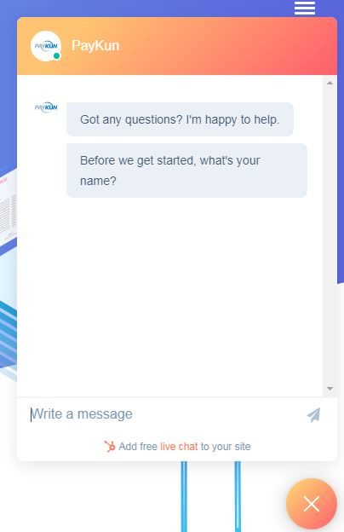

* **Bulk Product Adding Option**
* **Make an offer / EMAIL FORM**
* **Sell Your New or Surplus to us button**
* **Shipping Charges**
* **Individual Brand Page (Show Brand Infor | Brand Related Product | Add Option in admin to add brand with info)**
* **Google Translate**
* **Multiple Currencies**

*Please refer:* [*https://www.radwell.co.uk/*](https://www.radwell.co.uk/)

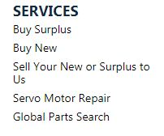

* **Search box in the Centre**



* **Bulk Quantity Discount**

*Please refer:* [*https://www.industrybuying.com/grain-processing-machine-agripro-AGR.GRA.62125493*](https://www.industrybuying.com/grain-processing-machine-agripro-AGR.GRA.62125493)

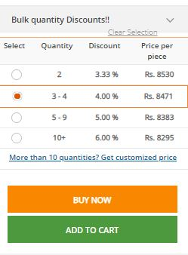

* **Blog Section**

When we add a product, it should be published as a blog

* **Link on the Brand Carousel**

*Please refer:*

<https://aeliyaeng.net/>

* **Product Description Tabs**

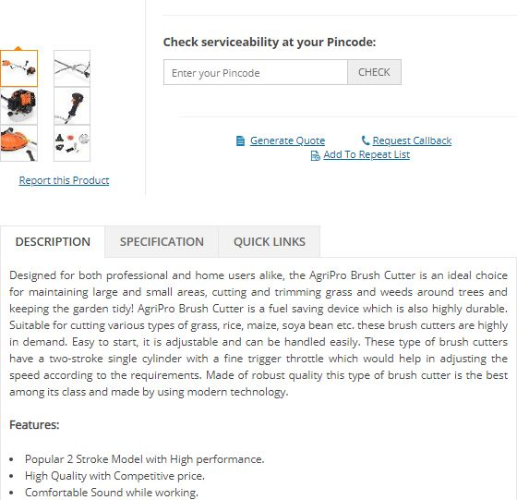

* **Generate Quote**



<https://www.industrybuying.com/brush-cutter-agripro-AGR.BRU.71517160/>

* **Discount Module**

